# Outcome Preparation Guidelines

Unit 4, AOS 1, Chinese Revolution.

This document is designed to help you get prepared for the First China SAC. You should aim to work through the tasks and submit as many practice tasks to me as you can.

## https://expertbeacon.com/sites/default/files/Blooms%20Taxonomy.jpg

Below is a checklist of work to get through before the SAC. The tasks will be explained in more detail below. This checklist is based on Bloom’s Taxonomy. Remember that you will find the things at the bottom of the checklist really hard if you don’t have the proper grounding in terms of ‘remembering’ and ‘understanding’.

|  |  |  |
| --- | --- | --- |
| Item number | Task | Done? |
| 1 | Note taking on Chapter 2 of Ryan |  |
| 2 | Note taking on Chapter 3 of Ryan |  |
| 3 | Consolidation of Chapter 2 and 3 notes |  |
| 4 | Thematic mind map of Period 1898-1911 |  |
| 5 | Thematic mind map of Period 1911-49 |  |
| 6 | Rote learning of historians quotes for Period 1898-1911 |  |
| 7 | Rote learning of historians quotes for Period 1911-49 |  |
| 8 | Completion of Practice SAC to time |  |
| 9 | Completion of additional practice questions |  |

## Note taking on Chapter 2 of Ryan

I think most of you have done this which is great. You should have detailed notes of the below things in your preferred note taking system (book or computer). This is critical for the ‘remember’ stage of the pyramid. More detail is going to help you here.

|  |
| --- |
| The Hundred days of Reform |
| Cixi’s Coup |
| The Boxer Uprising |
| The beginnings of reform |
| The Last Emperor |
| Sun Yat-sen and the Tongmenghui |
| The Revolution of 1911 |
| Yuan Shikai and Republican China |
| New Culture Movement |
| The Chinese Communist Party |
|  |
|  |
|  |

Here is a timeline from that part of the course that may help you:

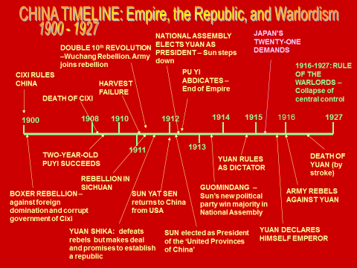

## Note taking on Chapter 3 of Ryan

Same as above, but you should have the following things in your notes:

|  |
| --- |
| The United Front |
| The Northern Expedition |
| The White Terror |
| Communists in Crisis |
| The Jiangxi Soviet |
| The Nationalist Decade |
| The Long March |
| The second united front |
| The Yan’an Way |
| The Second Sino-Japanese War |
| The Chinese Civil War |

## Consolidation of Chapter 2 and 3 notes

We spoke about this in class. This involves you going over your notes and condensing them down to the 3-5 most important pieces of information. For me this would be key stats, dates or people involved, as well as why the event is significant. The fact files you did for holiday homework will help you a lot with this. Below is a screenshot of what this might look like.

Tasks 1 and 2 have allowed you to understand the event in detail. This activity allows you to remember the most important things you need to put in your answers. Doing this now will be GOLD in a few months when you need to get across the whole year’s content very quickly.

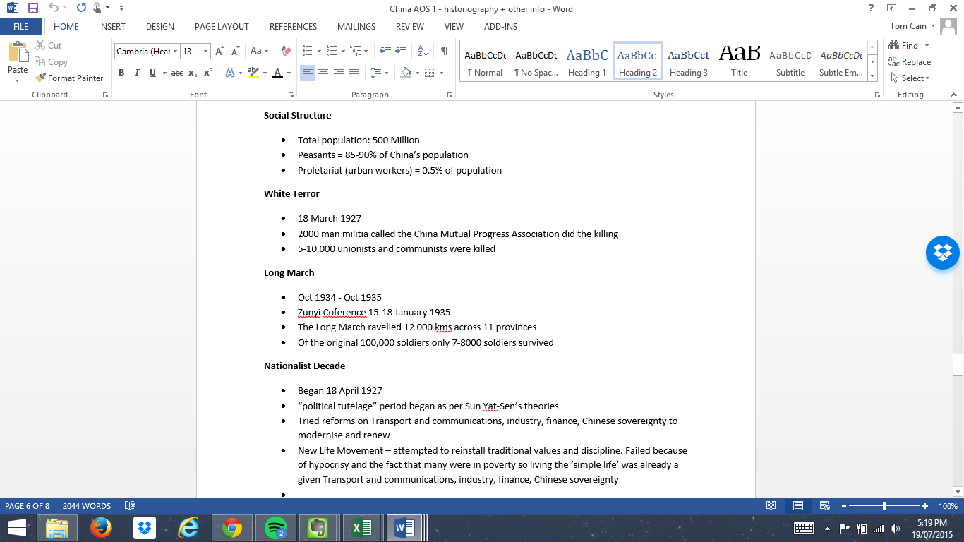

## & 5. Thematic Mind Maps

We did this briefly in class. Using your notes and the textbook identify the major themes that you see in each period.

The SAC is going to ask you one question on each of these periods. We began the mind mapping task in class, but you will get a lot out of this exercise if you do it yourself and in more detail. You will find it easier to argue that a certain theme is important if you actually believe that it is.

This will allow you to answer the 10 mark questions thematically, which is a huge benefit. You can check off what the source covers against the themes and structure your strengths and weaknesses more easily.

## & 7. Rote learning of historians’ quotes

This will be way easier after you’ve done the mind mapping activity. You should try and get a historians quote memorised for each of your major themes, either saying why this thing was important or wasn’t important to the revolution.

Any big gaps in your historians list send me an email and I’ll see what I can find to help you out. DON’T do this the night before the SAC.

Rote learning just means learning things through repetition. I believe it’s the best way for most people to commit things to memory, but that may just be because it’s what works for me. Use the technique that works best for you. If it were me learning these (it was once), I would just write them out a bunch of times until I can write them without thinking.

## Completion of practice SAC

Once you’ve done all the above, you’re ready to do the Practice SAC. The practice SAC is included at the end of this document. This is REALLY IMPORTANT and something that most of us haven’t done in the past to help us prepare. If you want to do better than others, or better than you did last time, make sure you do this and hand it to me with enough time to give you feedback before the SAC. **Mon 27th of July at the latest.** Scan it, take a photo, give it to me in person whatever works.

Take note of the changes to time. You only have 80 minutes to do two questions this time, last time you had 90. This will make it harder so make sure you’ve worked out what you can write in that time. More questions answered, less well is better than some good ones and some left blank – work out how you get the most marks in the time.

## Completion of other practice tasks

I’ve attached some other practice tasks for you to use. If you can get these done and submitted as well as the above you’re really putting in the effort required to do well in this SAC. Well done! Remember what we’ve learned about the importance of practice – it’s the only thing that’s going to make you better at something. Do these to time as well. 40 mins for each source.

If you’ve done those, it’s worth having a look at the past exam questions online. The good thing about these is you can review your answers against the examiner’s report.

***PRACTICE PRACTICE PRACTICE***

VCE HISTORY REVOLUTIONS

PRACTICE SAC

Unit 4 OUTCOME 1

AOS 1 – Revolutionary Ideas, Movements, Leaders and Events

|  |  |
| --- | --- |
| **Student Name:** | **Date:** |

|  |
| --- |
| **Instructions:**  You have 10 minutes reading time from 2-2:10  You have 80 minutes writing time from 2:10-3:30  You are to answer all questions on the answer paper provided |

**Question 1 (20 Marks)**

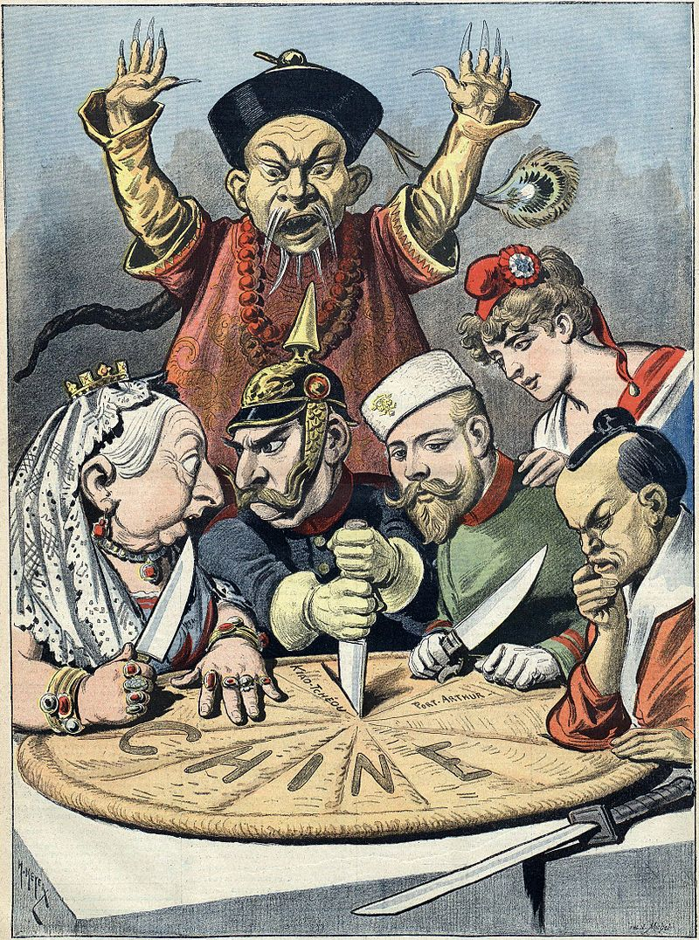

"China -- the cake of kings and... of emperors" An illustration from supplement to "Le Petit Journal", 16th January 1898

1. Identify two figures depicted in the representation.

2 marks

1. Identify two ways the representation depicts European industrial or imperial expansion in China

2 marks

1. Using your own Knowledge and by referring directly to this document, explain how foreign powers played a role in the development of the revolution by 1911.

6 marks

1. Evaluate to what extent this representation presents a reliable view of the causes of revolution in China in 1911. In your response, refer to different views.

10 Marks

**Question 2**

Mao Zedong on the Long March

Speaking of the Long March, one may ask, "What is its significance?" We answer that the Long March is the first of its kind in the annals of history, that it is a manifesto, a propaganda force, a seeding-machine.

The Long March is a manifesto. It has proclaimed to the world that the Red Army is an army of heroes, while the imperialists and their running dogs, Chiang Kai-shek and his like, are impotent. It has proclaimed their utter failure to encircle, pursue, obstruct and intercept us.

The Long March is also a propaganda force. It has announced to some 200 million people in eleven provinces that the road of the Red Army is their only road to liberation. Without the Long March, how could the broad masses have learned so quickly about the existence of the great truth which the Red Army embodies?

The Long March is also a seeding-machine. In the eleven provinces it has sown many seeds which will sprout, leaf, blossom, and bear fruit, and will yield a harvest in the future.

Mao Zedong, On Tactics against Japanese Imperialism, December 1935

1. What are two reasons given for the significance of the Long March?

2 Marks

1. Identify two reasons given why the Nationalists failed to defeat the Communists?

2 Marks

1. By referring to parts the source and using your own knowledge, explain the significance of the Long March in the development of the Chinese Revolution.

6 Marks

1. Evaluate this extract as evidence to explain how the Communist defeated the Nationalists by 1949. In your response refer to different historians’ views.

10 Marks

## Other Practice Questions



**a.** Identify **two** features of the documents which comment on Japan’s treatment of China in the period 1931-1935. (2 marks)

**b.** Identify **two** features of the representation (not listed in **a.** above) which comment on the resistance to Japan’s occupation of Chinese territory in the period 1931-1935. (2 marks)

**c.** Using your own Knowledge and by referring directly to aspects of the document, explain the impact of the Japanese occupation of Manchuria in 1931 and the subsequent Sino-Japanese war 1937-1945. (6 marks)

**d.** Evaluate the usefulness of this representation in assessing the response of the Nationalists and the CCP to the Japanese invasion and occupation of China 1931-1945.

In your response refer to different views of the occupation.

(10 marks)



1. Identify **two** figures appearing in the crowd in the representation. (2 marks)
2. Identify **two** different symbols used in the representation to suggest European industrial or imperial expansion in China. (2 marks)
3. Using your own Knowledge and by referring directly to this document, explain how foreign powers played a role in the development of the revolution by 1911. (6 marks)
4. Evaluate to what extent this representation presents a reliable view of the causes of revolution in China in 1911. In your response, refer to different views.

Refer to the views of others in your response.

(10 marks)

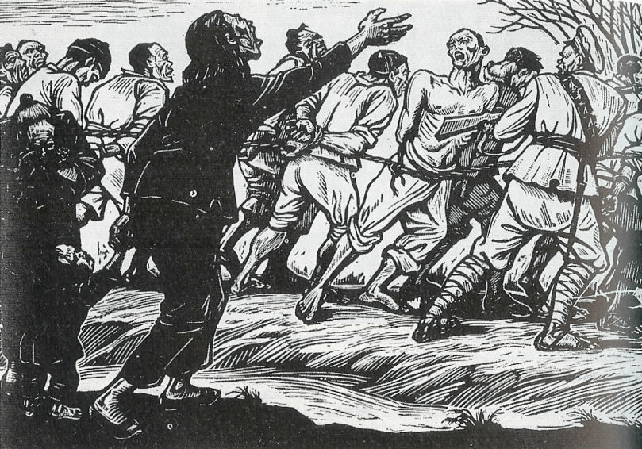

How the Nationalists do there recruiting.

1. Identify two groups shown in the document. (2 marks)
2. Identify two symbols which identify the attitude of common Chinese towards the Nationalists recruiting policies. (2 marks)
3. Using the document and your own knowledge explain the significance of the policy of recruitment by the Nationalists in the development of the revolution in China. (6 marks)
4. Evaluate the extent to which this document provides a reliable view of the causes of the Revolution? In your response refer to different views of the Revolution. (10 marks)



**a.** What tactical response was advocated at the National Conference of the Communist Party to the Japanese attack?

2 marks

**b.** According to the report what was the basic force for defeating Japanese imperialism and traitors?

2 marks

**c.** Using your own knowledge and the representation, describe the response of the Communist Party to Japanese expansion in China in 1937?

6 marks

**d.** Discuss the usefulness of this document in understanding the response of the Chinese to the outbreak of war with Japan in 1937. In your response refer to different views of the significance of the Second Sino-Japanese in strengthening the position of the CCP.

10 marks